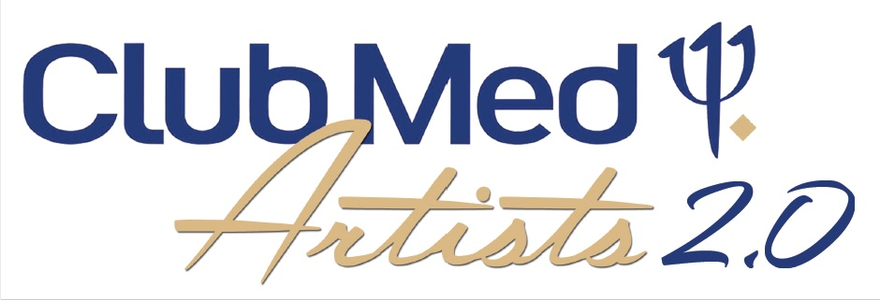
INSTRUCTIONS AND STEPS TO SIGN-UP FOR CLUB MED ARTISTS N.A.M

PLEASE NOTE THIS IS A BARTER EXCHANGE ( NO SALARY OR FLIGHTS INCLUDED) FOR YOU AND 1 GUEST IN 1 OF 9 OF OUR ALL INCLUSIVE RESORTS

IN EXCHANGE OF PERFORMING LIVE MUSIC 5 TIMES 60 OR 90 MINUTES BASE ON A 7 DAY STAY

1. Please contact our booking team at cmabookings@gmail.com

. send us direct videos or links of your musical project or other
. must be short bits of Internationnal cover songs only ( no originals)
. a complete songlist
. HD pics
. technical rider
. CM references or others

2. If accepetd our team will contact you by e-mail to offer you the available dates and destination we cover.Below you will find the list of our resort and our musical needs,

Sandpiper Florida solo-duo-trio- quatuor
Punta Cana Dominican Republic 1 solo artists
Punta Cana Dominican Republic 1 live band
Cancun Mexico soloduo-trio-quatuor
Miches Dominican. Republic solo-duo-trio-quatuor
Ixtapa Mexico solo-duo-trio-quatuor
Caravelles Guadeloupe 1 solo artist
Turks and Caicos 1 solo artist
Boucaniers Martinique 1 solo artist
Columbus Bahamas 1 solo artist

Please note that Turks and Caicos, Columbus Bahamas. Caravelles Guadelupe and Boucaniers Martinique are only for long period stay (30 days minimum) with flights included TBC for Turks and Columbus.

3. After a destination and dates are selected by CMA and the artist(s), a booking form must be sent to our booking team including:

. resort name
. arrival and departure date
. full artist name and guest with DOB
. a credit card number with expiration dates and security code ( if you have kids between 2 and 16 years old that you would like to add to your reservation at 75 US $ per day TBC at all time)
. once a confirmation number is given by reservation center you can go ahead and buy your flights tickets,

PLEASE NOTE THAT ONCE A CONFIRMATION NUMBER IS GIVEN WE WONT BE ABLE TO CHANGE OR MODIFY DATES . ARTISTS .GUEST UNDER ANY CIRCUMSTANCES AS THE BOOKING FORMS CLEARLY EXPLAIN

4. CLUB MED WILL:

. ORGANIZE AND PAY GROUND TRANSPORTATION TO AND BACK FROM THE VILLAGE
. ANIMATION RESPONSABLE WILL GIVE Yoo YOUR PERFORMING SCHEDULE ( may change)
. CLUB MED WILL SUPPLY COMPLETE PA SYSTEM AND TECHNICIAN AND FULL BACKLINE (where applicable)

5. RULES AND REGULATIONS ARTIST MUST FOLLOW :

. ANY USE OR POSSESSION OF DRUGS IS COMPLETLY FORBIDEN, ARTISTS AND GUESTS WILL IMMEDIATLY HAVE TO LEAVE THE VILLAGE WITHOUT WARNING AT YOUR EXPENSE.

. ALCOOL, TOBACCO AND TIP JAR ARE NOT PERMITTED WHILE PERFORMING

. YOU WILL DOWNLOAD THE CM APPLICATION AND FIND THE DRESS CODE ( theme colors to follow) FOR THE VILLAGE YOU ARE VISITING

. Artist cant perform songs with swearing or vulgar content

. KINDNESS BEEING ONE OF CLUB MED TRADE MARK: YOU WILL AT ALL TIME RESPECT OUR GMS ( CLIENTS), G.O TEAM AND G.E (CM STAFF)

. BE PRESENT AT SOUNDCHECK 30 MINUTES BEFORE PERFORMANCE FOR SOUNDCHECK

. 10 days before departure ARTISTS MUST SEND COMPLETE FLIGHT INFORMATION to cmabookings@gmail.com (arrival & departure time, airline company and flight number, how many person to transport,please note we will only do 1 transfer in and 1 out,

. 2 days before departure Artist will send a quality HD pic to help promote your performances in the Village.

. Artists must be aware that at all time you represent CLUB MED STAFF & TEAM so an appropriate behaviour is requested at all time,

I read and agree to all the CMA rules and regulations.

Signature:____________________ Date: _________________

CLUB MED ARTIST

